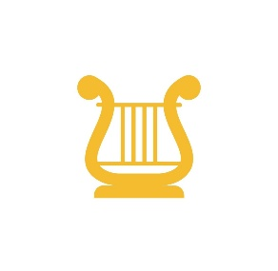

Kit Guidelines for Parents
Please note: Clyde Apollo Football Club kit remains the property of the Club and must be returned when a child leaves the Club.
1. The Training kit comprises of shorts, short-sleeved top and knee-length socks. This kit should only be worn for training nights or if instructed on matches by a coach.
2. The Home Match kit comprises of Maroon shorts, Maroon short-sleeved top and knee-length socks. The Goalie kit will be Green long sleeved top, Green Shorts and socks. This kit should only be worn for match days events.
3. The Away Match kit comprises of Black shorts, Yellow & Black stipred shortsleeved top and knee-length socks. The Goalie kit will be Pink long sleeved top, Pink Shorts and socks. This kit should only be worn for match days events.
4. The Club will endeavour to replace playing kit every two seasons.
5. Parents are requested to look after the kit as they will be asked to replace any lost or damaged kit. When a child leaves the Club, all kit must be returned to the Football Club except for the socks.
6. Please keep kit clean. It should be washed on a gentle cycle. The following guidelines apply to kit with printed logos, numbers and lettering.
- Do not tumble dry
- Keep away from radiators
- Football tops should be turned inside out for washing
- Dry flat to avoid damaging the printing
- Do not iron any printed area
7. You will also be issued with a club jacket & Zipper which can be worn on any team activity but will be removed for matches.
8. If you have any questions about the kit, please see your team coach.

Player name:
Signed:
Date:

